Lucan Community College
3rd Year Higher Level Mathematics Revision Sheet 1 – Mr Duffy
Quadratic Equations

1. Solve for
2. Solve for
3. Solve for 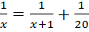
4. Solve correct to two decimal places
5. Express the following in the form and hence, solve the equation
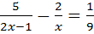.
6. Solve the equation
Hence, find the four values of t for which 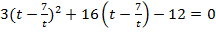
7. A football club runs a raffle each week with a prize fund of €900. In the first week the prize was shared equally among people. In the second week the prize fund was shared equally among people and each person received €15 more than the winners on the first week.
Write an equation and solve it to find the value of .
8. The equation has answers Find one set of values of p, q and r.
9. If is one root of the equation find:
- The value of k (ii) the other root.

