6th Year November Assessment
Mr Duffy
Please answer all questions in the spaces provided.
Name: _____________________________________

Section A – Concepts & Skills
Question 1
The circle c has centre P(– 2, –1) and passes through the point Q(3, 1).
(a) Show c, P, and Q on a co-ordinate diagram.
(b) Find the radius of c and hence write down its equation.

(c) R is the point (1, 6). By finding the slopes of PQ and QR, show that QR is a tangent to c.

Question 2
The diagram below shows a shape with two straight edges and one irregular edge. By dividing the
edge [AB] into five equal intervals, use the trapezoidal rule to estimate the area of the shape.
Record your constructions and measurements on the diagram. Give your answer correct to the
nearest cm².
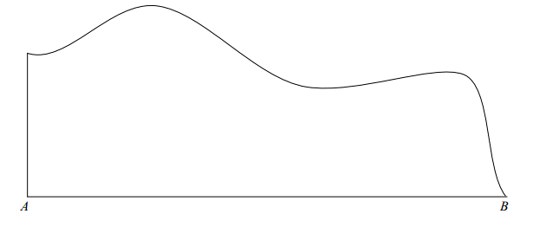

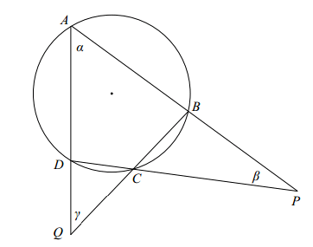
Question 3
ABCD is a cyclic quadrilateral.
The opposite sides, when extended, meet at P and Q, as shown.
The angles α, β, and γ are as shown.
Prove that β + γ = $180-2α$.

Question 4

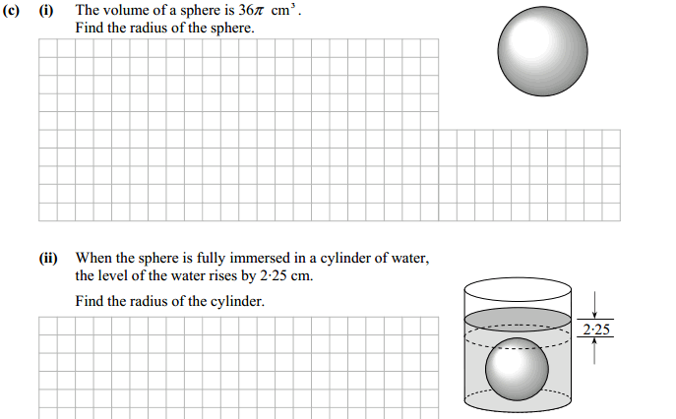

Section B - Contexts & Applications

Question 5
(a) The diagram below is a scale drawing of a hopper tank used to store grain. An estimate is
needed of the capacity (volume) of the tank. The figure of the man standing beside the tank
allows the scale of the drawing to be estimated.
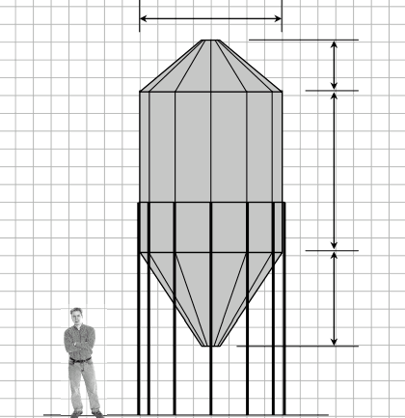

(i) Give an estimate, in metres, of the height of an average adult man.

Answer:

(ii) Using your answer to part (i), estimate the dimensions of the hopper tank. Write your
answers in the spaces provided on the diagram.

(iii) Taking the tank to be a cylinder with a cone above and below, find an estimate for the
capacity of the tank, in cubic metres.

