Formal Proofs for Junior Cert Higher Level
The following five theorems must be learned by heart. One of these may appear on the exam in June. You must learn them exactly as they appear here, including diagrams and constructions.
1. Angles in triangle add to 180
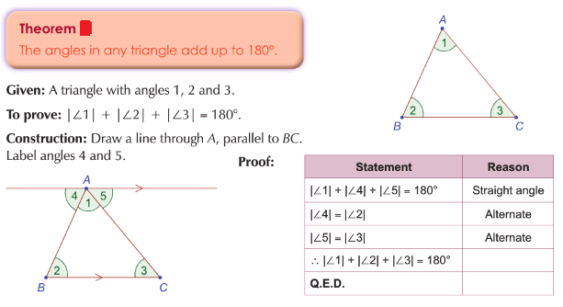
2. The exterior angle of a triangle is equal to the sum of the interior opposite angles
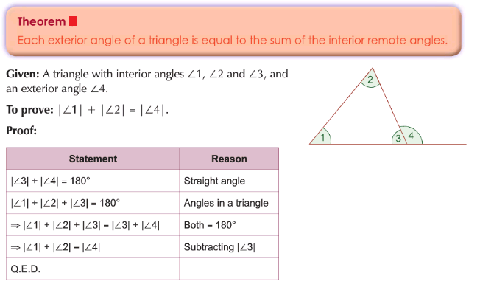
3. In a parallelogram opposite sides and angles are equal in measure
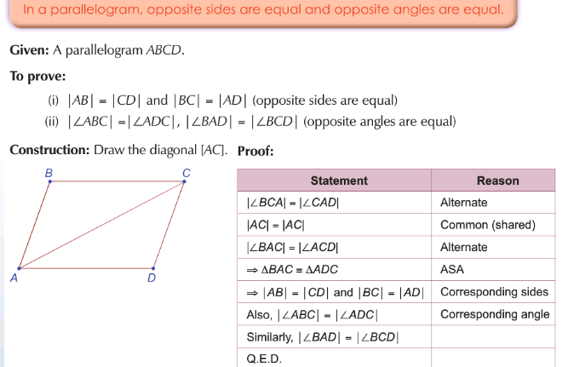
4. Pythagoras: In a right angled triangle the square of the hypotenuse is equal to the sum of the squares of the other two sides
Theorem: In a right-angled triangle, the square of the length of the side opposite to the right angle is equal to the sum of the squares of the other two sides.
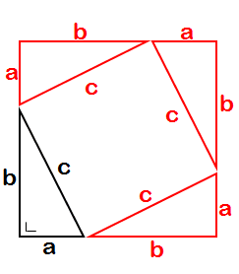
Given: Right-angled triangle abc
To Prove: a² + b² = c²
Construction: Three right angled triangles as shown
Proof: Area of large sq. = area of small sq. + 4(area D) (a + b)² = c² + 4(½ab)
a² + 2ab +b² = c² + 2ab
a² + b² = c²
Note: To help with the construction you should draw a square of side 7cm. Mark off lengths of 3cm and 4cm on each side and let a = 3cm and b = 4cm. This will leave you with a square of side 5 ( = c) in the middle

5. Angle at centre of circle is twice angle at circumference standing on same arc
