**Lucan Community College – 5th Year Summer Examinations 2012**

**Mathematics – Higher Level – Ms Twyford & Ms Coghlan**

Please answer all of the following questions on the examination paper. All calculations must be shown clearly to obtain full marks. Additional paper, graph paper and Tables Books are available from the invigilators. Good Luck – if you leave it blank you can only get 0 marks!

Q1. (a) Solve for *x*, *y*, *and z.*

$3x-y+3z=1$

$x+2y-2z=-1$

$4x-y+5z=4.$



(b) (i) Solve for *x*

$\left|3x+5\right|<4$

**

(ii) Solve



(c) (*x* - *t*)2 is a factor of *x*3 + 3*px* + *c*.

Show that

**(i)** *p* = -*t* 2  **AND (ii)** *c* = 2*t3*.



Q2. (a) The line $y=\frac{3}{2}x-2$ crosses the *x*-axis at the point P and the *y*-axis at the point Q.

(i) Write down the slope of the line

(ii) Find the coordinates of P and Q.

(iii) Calculate the area of the triangle OPQ, where O is the origin.

(b) (i) Find the equations of the two lines parallel to 4*x* - 3*y* + 8 = 0 if the perpendicular distance from the origin to each line is 4.

(ii) *M* is the line $tx+\left(t+2\right)y-11=0,$ where $t ϵ R.$ (a) Write down the slope of *M* in terms of t and (b) If the angle between *M* and the line $x-2y-1=0$ is $45°,$ find the two possible values of *t*.

(c) When the interest rate for deposits is 7.5%, a small building society attracts €35 million of savings. When the rate is increased to 8.5%, the savings increase by €2 million. Assuming that the graph of savings against interest rates is linear for interest rates between 5% and 12%,

 (i) sketch the graph of savings (in € million) against interest rates (%) in this interval, with interest rates on the horizontal axis

(ii) find the equation of the line

Use your **equation** to

(i) find the value of savings attracted by a rate of 11.5% and

(ii) find the interest rate needed to attract savings of €40 million.

Q3. (a) Find the two real numbers *a* and *b* such that 

(b) (i) Show that is a root of the equation  and find the other root of this equation.

(ii)  and .

Evaluate giving your answer in the form 

(c) (i) Simplify  and write your answer in the form 

(ii) Hence, evaluate 

Q4. The shapes of the histograms of four different sets of data are shown below.

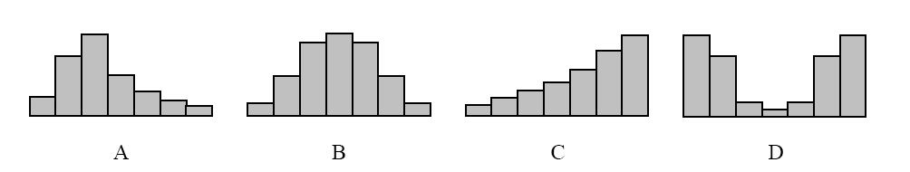

**(a)** Complete the table below, indicating whether the statement is correct (✓) or incorrect (x)

with respect to each data set.

|  |  |  |  |  |
| --- | --- | --- | --- | --- |
|  | **A** | **B** | **C** | **D** |
| The data are skewed to the left |  |  |  |  |
| The data are skewed to the right |  |  |  |  |
| The mean is equal to the median |  |  |  |  |
| The mean is greater than the median |  |  |  |  |
| There is a single mode |  |  |  |  |

(b) Assume that the four histograms are drawn on the same scale.

State which of them has the largest standard deviation, and justify your answer.

Answer:

Justification:



Q5.

The function $f:x→3\sin\left(2x\right)$ is defined for $∈R$.

(a) Complete the table below

|  |  |  |  |  |  |
| --- | --- | --- | --- | --- | --- |
| $$x$$ | 0 | $$\frac{π}{4}$$ | $$\frac{π}{2}$$ | $$\frac{3π}{4}$$ | $$π$$ |
| $$2x$$ |  |  |  |  |  |
| $$\sin\left(2x\right)$$ |  |  |  |  |  |
| $$3\sin\left(2x\right)$$ |  |  |  |  |  |

(b)

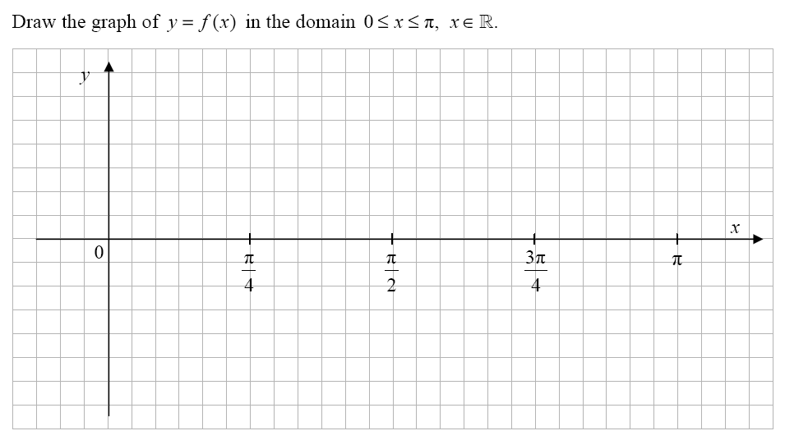

**(c)** Write down the range and the period of *f*.

Range = ___________ Period = ___________

Q6. (a) Find the size of the largest angle in a triangle with sides of length 7m, 8m and 9m.



(b) In a triangle *ABC,*  , and the area of the triangle ABC is . Find two values of the angle . Make a sketch of the resulting triangles.



(c) A and B are the goalposts at one end of a football pitch and F is the corner flag. A, B and F lie in a straight line with  and A player is at position P, as shown in the diagram, such that and .

(i) Draw a DIAGRAM of this scenario here.



(ii) Calculate 



(iii) Calculate 



(iv) Calculate 



Q7. 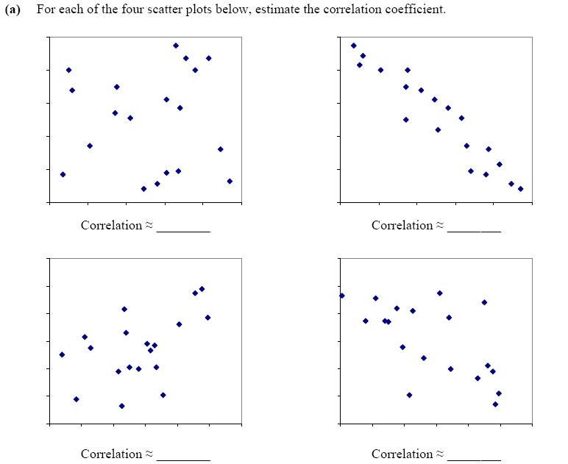

(b)

|  |
| --- |
| Using your calculator, or otherwise, find the correlation coefficient for the data given in the table.  Give your answer correct to two decimal places. |
| Answer: __________ |

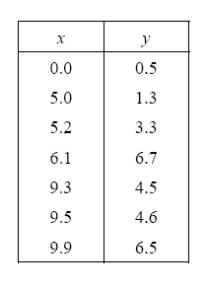

Q8. Some research was carried out into the participation of girls and boys in sport. The researchers selected a simple random sample of fifty male and fifty female teenagers enrolled in GAA clubs in the greater Cork area. They asked the teenagers the question: *How many sports do you play?*

The data collected were as follows:

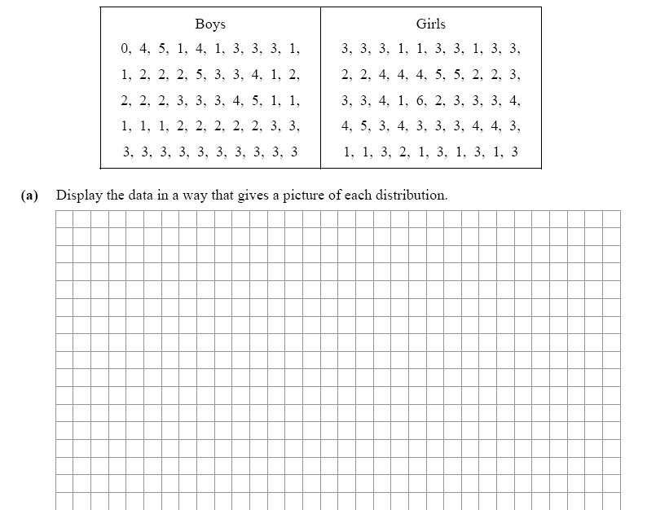

(b) State one difference and one similarity between the distributions of the two samples.

