**Lucan Community College Mathematics Department Mr Duffy**

6th Year - September 26 2012 – Coordinate Geometry of the Circle

**Finding the point of intersection of a line and a circle**

This example is taken from the 2006 Leaving Certificate Ordinary Level Paper 1

_________________________________________________________________

**Q3. (b) Solve for x and y: $x-2y=10$**

$x^{2}+y^{2}=20$

_________________________________________________________________

Step 1: Label both equations as (1) and (2)

$x-2y=10$...........(1) [always the ‘easier’ looking equation]

$x^{2}+y^{2}=20$...........(2)

Step 2: Rewrite equation (1) so that x is on its own on the left hand side and all other ‘stuff’ is on the right hand side. Remember to change signs when travelling across the equals sign.



Step 3: We now have a new expression for x. Use this expression and substitute it for x into equation (2), i.e. rewrite equation (2) and wherever you see x, replace it with (**)

$x^{2}+y^{2}=20$

$({10+2y)}^{2}+y^{2}=20$ replace x with 10 + 2y

$\left(10+2y\right)\left(10+2y\right)+y^{2}=20$ expand the bracket to be squared

$10\left(10+2y\right)+2y\left(10+2y\right)+y^{2}=20$ set up multiplication of brackets

$100+20y+20y+4y^{2}+y^{2}=20$ multiply out the brackets

$5y^{2}+40y+100-20=0$ bring same terms together and let = 0

$5y^{2}+40y+80=0$ simplify

$y^{2}+8y+16=0$ divide all by 5

Step 4: Factorise our new expression to find values for y.

 $y^{2}+8y+16=$ 0

$$\left(y+4\right)\left(y+4\right)=0$$

Step 5: Notice that both brackets are the same, so we only have to let one of the brackets = 0 and solve to get our y-value

$y+4=0$

$y=-4$

Step 6: Replace this value of y into equation (1) to find a corresponding value for x. We always replace it into the ‘easier’ looking equation.

So, $x-2y=10$ **and we know that $y=-4$**

$x-2\left(-4\right)=10$

$x+8=10$

$x=10-8$

$x=2$

So, the answer to our question is *x* = 2, *y* = -4.

This means that when we substitute *x* as -2 and *y* as -4 into both equations at the same time they both work out (they satisfy both equations simultaneously!)

A Graphical Representation of this scenario looks like this........

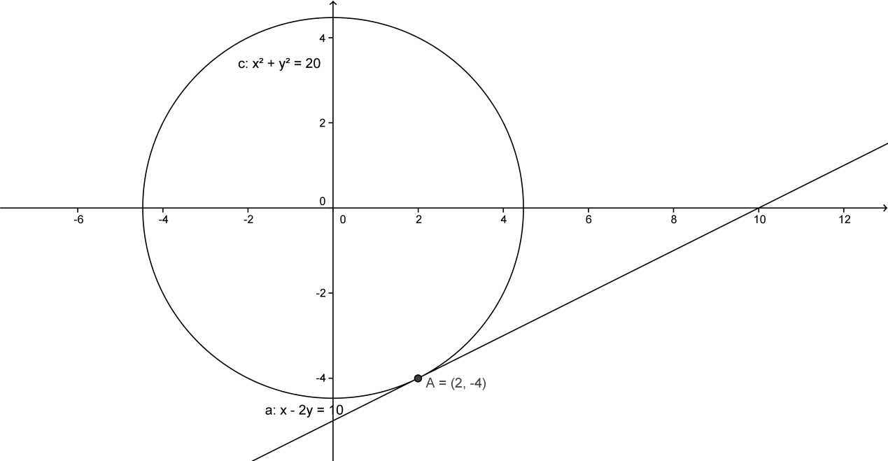

Scribble Box for Notes/Rough Work

Now try these questions in the spaces provided

**2004 LC OL Paper 1**

**Q3 (b) Solve for x and y **



**2003 LC OL Paper 1**

**Q3. (b) (i) Solve for x and y $y=10-2x$**

$x^{2}+y^{2}=25$