Lucan Community College Summer Examinations 2012
5th Year Mathematics – Mr Duffy
Answer all questions in the spaces provided – Good Luck
Name: ____________________________

Q1. A girl and a boy are each asked to think of a whole number from 1 to 10. The outcome of this experiment is recorded as a pair of numbers. For example, if the girl picks 3 and the boy picks 1, this is recorded as (3, 1).

(a) Write out three possible outcomes of this experiment.
(b) How many different possible outcomes are there?
(c) Write out all of the outcomes in which the two children pick the same number.
(d) Suppose that all numbers are equally likely, and that one child’s choice has no effect on the other’s choice. What is the probability that the two children will pick the same number?
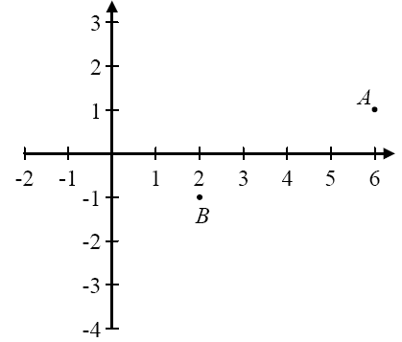
2. The points A(6, 1) and B(2, –1) are shown on the diagram.
(a) Find the equation of the line AB.
(b) The line AB crosses the y-axis at C. Find the co-ordinates of C.

(c) Find the ratio $\frac{\left|AB\right|}{\left|AC\right|}$ , giving your answer in the form $\frac{p}{q}$ , where p and q are whole numbers.

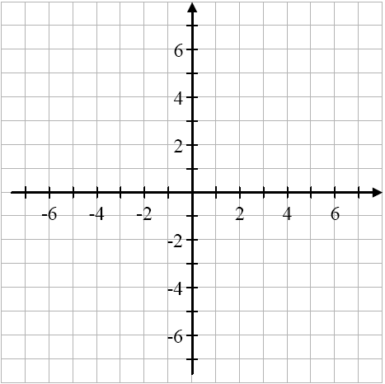
Q3. The points A, B, and C have co-ordinates as follows:
A (–4, 1)
B (–1, –5)
C (4, 5)
(a) Plot A, B, and C on the diagram, and show the triangle ABC.

(b) Find the slope of AB and the slope of AC.

Slope of AB = ____________ Slope of AC = ___________________

(c) Show how to use your answers to part (b) to decide whether this triangle is right-angled at A.

Q4. The line l has equation$5x+12y-60=0$ . It cuts the x-axis at A and the y-axis at B.
(a) Find the co-ordinates of A and the co-ordinates of B.

(b) The point P has co-ordinates (5, 3). Show the point P and the line l on a co-ordinate diagram.

(c) Prove that P does not lie on l.

Q5. Whenever a baby is born, one of the things measured and recorded is the baby’s weight. The birth-weights of a sample of babies are summarised in the table below.
Weight in kg. | 2.2-2.6 | 2.6-3.0 | 3.0-3.4 | 3.4-3.8 | 3.8-4.2 | 4.2-4.6
Number of babies | 12 | 40 | 64 | 56 | 24 | 4

(a) How many babies were in the sample?

Answer: ___________
(b) Draw a histogram of the data.
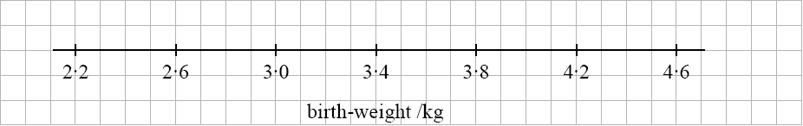

(c) Complete the following sentence, by using the table and/or the histogram to make an estimate:
“On average, these babies weighed about __________ kg at birth.”
(d) One of the babies weighed 3·675 kg when she was born. How would you describe this baby’s weight in comparison to the other babies?

(e) A weight of less than 2·5 kg is called a “low birth-weight”.
Estimate the number of low-birth-weight babies in this sample.

Approximately 60 000 babies were born in Ireland in 2005. According to a survey, 20% of the mothers smoked cigarettes during the pregnancy. Suppose that our sample was chosen from among these babies whose mothers smoked.

(f) What is the size of the population from which the sample was drawn?
(g) Using the information from the sample, estimate the number of low-birth-weight babies in that population.

(h) Explain why the sample cannot tell us exactly how many such babies were in the population.

(i) The mean birth-weight for all babies born in Ireland that year was 3·51 kg. Do you think that the information from our sample shows that smoking during pregnancy affects the baby’s birth weight? Explain your answer giving two reasons for your answer.

Q6. (a) Using a calculator, or otherwise, find the mean and standard deviation of the data in the following frequency table.
x | 20 | 30 | 40 | 50
f | 16 | 38 | 26 | 20

Mean = ___________ Standard Deviation = _____________

(b) Below is a stem-and-leaf plot of the heights of a group of students, in centimetres.

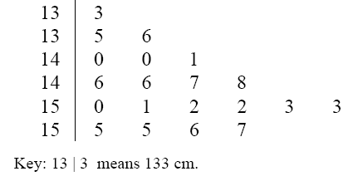

(i) How many students are in the group?
Answer: _____________
(ii) What is the range of heights in the group?

(iii) What percentage of the students is between 145 cm and 154 cm in height?

Q7. (a) Helen has enough credit to download three songs from the internet. There are seven songs that she wants.

(i) How many different possible selections of three songs can she make?

(ii) If there is one particular song that she definitely wants, how many different selections can she now make?

(b) (i) Two fair coins are tossed. What is the probability of getting two heads?

(ii) Two fair coins are tossed 1000 times. How often would you expect to get two heads?

(c) Síle hands Pádraig a fair coin and tells him to toss it ten times. She says that if he gets ten heads then she will give him a prize. The first nine tosses are all heads. How likely is it that the last toss will also be a head? Tick the correct answer, and give a reason.

Extremely unlikely
Fairly unlikely
50-50 chance
Fairly likely
Almost certain

Reason:

Q8. The table below gives motor insurance information for fully licensed, 17 to 20-year-old drivers in Ireland in 2007. All drivers who had their own insurance policy are included.

 | Number of Drivers | Number of Claims | Average Cost per Claim
Male | 9634 | 977 | €6108
Female | 6743 | 581 | €6051

Questions (a) to (e) below refer to drivers in the table above only.
(a) What is the probability that a randomly selected male driver made a claim during the year?
Give your answer correct to three decimal places.

(b) What is the probability that a randomly selected female driver made a claim during the year?
Give your answer correct to three decimal places.

(c) What is the expected value of the cost of claims on a male driver’s policy?

(d) What is the expected value of the cost of claims on a female driver’s policy?

(f) A 40-year-old female driver with a full license has a probability of 0·07 of making a claim during the year. The average cost of such claims is €3900. How much should a company charge such drivers for insurance in order to show a surplus of €175 per policy?
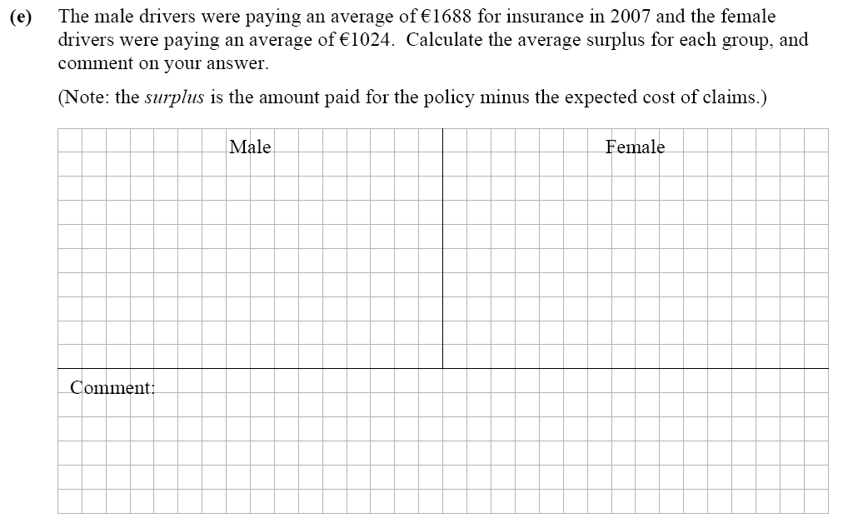
Q10. (a) Write 8% as a decimal.
Answer = ________
(b) A company borrows €15 000 for five years at an interest rate of 8% per annum (APR). If the company makes no repayments, how much will it owe at the end of the five years.

Q11. A piece of machinery in a factory is valued every three years. The table below shows the value every three years from the end of 1996 to the end of 2008.

Year | 1996 | 1999 | 2002 | 2005 | 2008
Value at end of Year € | 256,000 | 128,000 | 64,000 | 32,000 | 16,000

(i) Describe fully the pattern in the value of the equipment over time.

(ii) Suppose that this pattern continued. Complete the table below for the next two valuations.

Year | 2011
Value at end of year /€

(iii) The machinery will be scrapped when its value is €1000 or less. When will this happen?

(b) Ciara spends €1600 each year on heating her house. By adding extra insulation in the attic, she can reduce this by 15%.

(i) How much will Ciara save on her heating bills each year if she gets the insulation?

(ii) It will cost €920 to have the extra insulation put in. Ciara will get a grant of €200
towards this cost. How many years will it take for the savings on her heating bills to
recover the rest of the cost?

Q12. (i) A certain deposit account will earn 3% interest in the first year and 6% interest in the second year. The interest is added to the account at the end of each year.
If a person invests €20,000 in this account, how much will they have in the account at the end of the two years?

(ii) Show that, to the nearest euro, the same amount of interest is earned by investing the money for two years in an account that pays compound interest at 4·49% (AER).

Q13. The 2006 census shows that the number of males living in Ireland is about the same as the number of females.

(a) If a person is selected at random, write down the probability that the person is male.

(b) Four people are chosen at random. We are interested in whether they are male or female.

(i) Complete the sample space below showing the sixteen equally likely outcomes.

MMMM
MMMF

(ii) Hence, or otherwise, complete the table of probabilities below.

Four males | Three males  One female | Two males  Two females | One male  Three females | Four females
$$\frac{1}{4}$$

(iii) A person states the following: “If you pick four people at random, it’s more likely than not that you’ll get two males and two females.”
Is this statement correct? Justify your answer using the answer(s) to part (b).

Answer: ____________

Justification:

